User Survey Report for Sickle Cell and Thalassaemia Screening Laboratory User Survey 2025-2026 (UHBW)

Introduction
The Haematology Department at University Hospitals Bristol and Weston NHS Foundation Trust (UHBW) is committed to maintaining high standards of quality and service delivery in accordance with ISO 15189:2022 – Medical laboratories: Requirements for quality and competence.
In line with Section 8.6 – Evaluation and feedback from users, the laboratory is required to actively seek and monitor information relating to user perception, including whether the services provided meet the needs and expectations of its users. User feedback is an essential component of the quality management system and supports the identification of areas for improvement, as well as confirming areas of good practice.
The Sickle Cell and Thalassaemia Screening Laboratory User Satisfaction Survey was conducted as part of this ongoing commitment to quality assurance and continuous service improvement. The survey was designed to obtain feedback from users regarding various aspects of the screening service, including reliability, communication, quality of reporting, and accessibility of professional advice.
The findings from this survey are intended to:
- Evaluate the extent to which the service meets user requirements
- Identify any areas where improvements may be required
- Inform service development and quality improvement initiatives
Ultimately, the results contribute to ensuring that the Sickle Cell and Thalassaemia Screening service continues to provide a safe, effective, and user-focused service, in alignment with both organisational objectives and national standards.

Objectives
The objective of this survey was to assess the level of satisfaction of users of the Sickle Cell and Thalassaemia Screening Laboratory service by gathering structured feedback on key aspects of service delivery.
The survey aimed to evaluate user perception in relation to:
- The reliability and timeliness of results
- The quality and clarity of laboratory reports
- The standard and accessibility of professional advice
- The effectiveness of communication pathways between the laboratory and its users
In addition to quantitative responses, the survey also sought qualitative feedback through open-ended questions, enabling users to highlight areas of good practice and to suggest potential improvements to the service.
The information obtained from this survey enables the laboratory management team to:
- Review current service provision against user expectations
- Identify areas requiring improvement or further investigation
- Support continuous quality improvement in line with ISO 15189:2022 standards
The outcome of this process ensures that the laboratory remains responsive to user needs and continues to deliver a high-quality, patient-centred service.

Response to the Survey

This short survey was designed by the Lead Biomedical Scientist for the Screening Laboratory to elicit users’ views about the Laboratory service at University Hospitals Bristol and Weston NHSFT Laboratory Services (UHBW). Participants were encouraged to complete the online User Survey distributed to the Screening Midwives. The survey was available to all the users in the Trust. In total, 8 responses to the survey were received.

Method Used

The Questionnaire
The questionnaire was designed to assess user satisfaction with the Sickle Cell and Thalassaemia Screening Laboratory service. It consisted of a series of structured statements, where users were asked to indicate their level of agreement using a Likert scale ranging from “Strongly Agree” to “Strongly Disagree.”
The statements focused on key aspects of service delivery, including:
- The reliability and timeliness of results
- The quality of professional advice provided by the laboratory
- The clarity and usefulness of laboratory reports
- The availability of professional advice when required
- The effectiveness of communication pathways between the laboratory and its users
- Confidence in the communication of urgent or unexpected results
- Overall satisfaction with the service and willingness to recommend it to colleagues
In addition to the structured questions, respondents were given the opportunity to provide free-text feedback through open-ended questions. These questions aimed to capture user perspectives on:
- Potential improvements to the Sickle Cell and Thalassaemia screening service
- Improvements to results delivery
- Any additional comments regarding the service
An overall service rating was also included to allow users to provide a general assessment of the service received.

Survey Distribution and Data Collection
The survey was distributed electronically using Microsoft Forms and made available to users of the Sickle Cell and Thalassaemia Screening service across the Trust.
Users were invited to participate voluntarily, and responses were submitted anonymously to encourage honest and unbiased feedback. The survey remained open for a defined period, during which users were able to complete the questionnaire at their convenience.

Assessment Criteria
The laboratory applies a predefined satisfaction target in line with its quality management system and ISO 15189:2022 requirements.
For each statement, a satisfactory response is defined as:
- “Strongly Agree” or
- “Agree”
The target for user satisfaction is set at greater than 90% satisfactory responses for each question. Any results falling below this threshold are identified as requiring further review and potential action to ensure continuous service improvement.

Data Analysis
Responses were collated and analysed to determine the percentage of satisfactory and unsatisfactory responses for each statement; overall trends in user satisfaction and key themes arising from qualitative feedback.
Due to the relatively small number of responses, results have been interpreted with appropriate caution, with particular attention given to identifying recurring themes and meaningful patterns, rather than isolated responses.

Results
The following graphs illustrate the results of the responses for each of the statements:

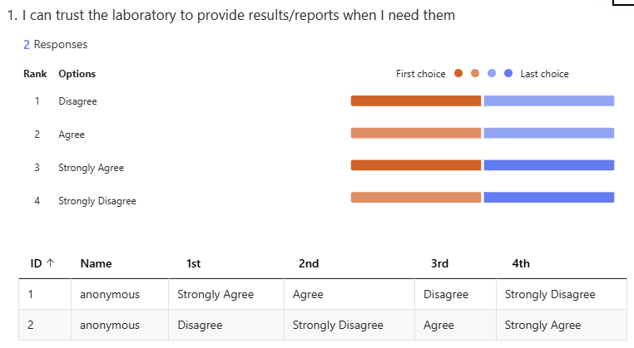
Answered: 2. Skipped: 6.

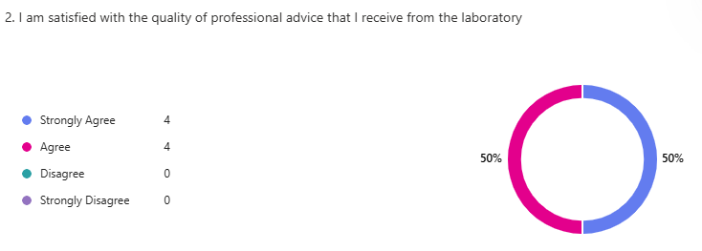
Answered: 8. Skipped: 0.

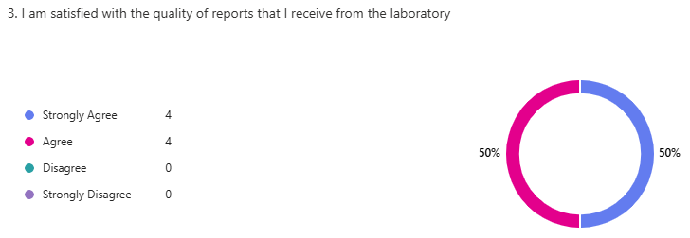
Answered:8. Skipped: 0

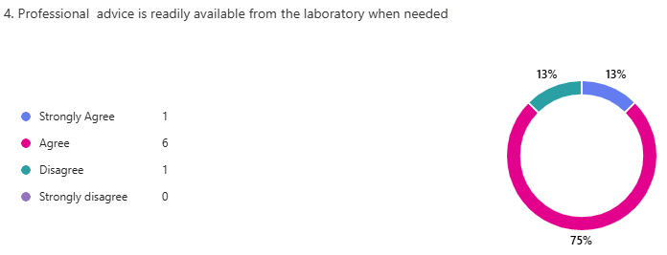
Answered: 8. Skipped: 0.

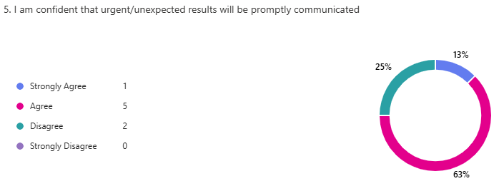
Answered: 8. Skipped: 0

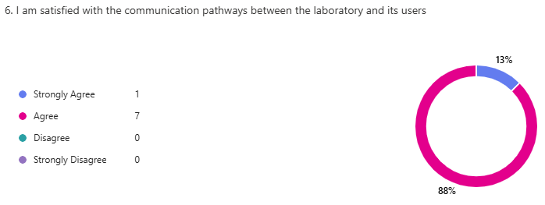
Answered: 8. Skipped: 0

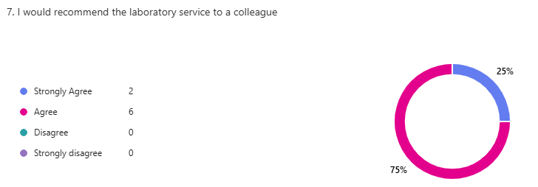
Answered: 8. Skipped: 0

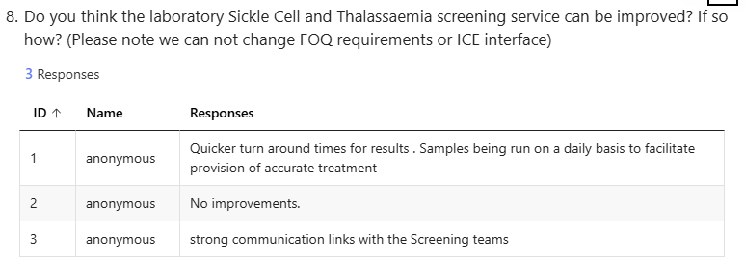
Answered: 3. Skipped: 5

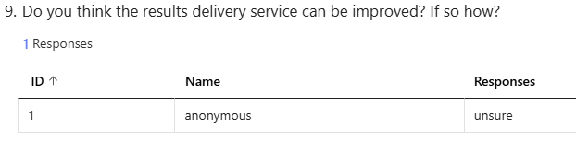
Answered: 1. Skipped: 7

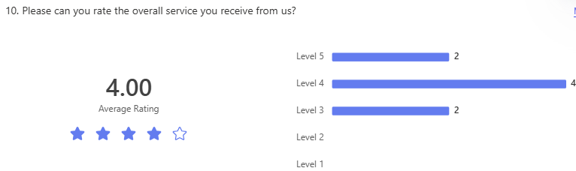
Answered: 8. Skipped: 0

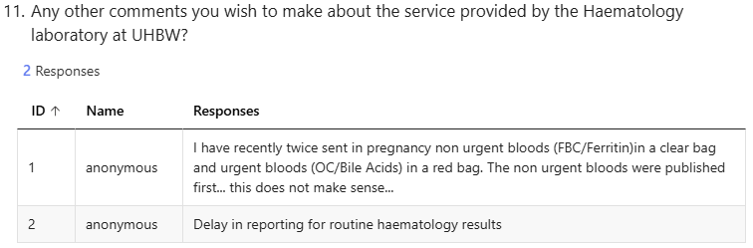
Answered: 2; Skipped: 0

Result Analysis

A total of 8 responses were received for the 2025–2026 Sickle Cell and Thalassaemia Screening Laboratory User Survey. While the number of respondents is relatively small, the results provide a useful overview of user perception, particularly when considered alongside trends identified in previous surveys. However, the findings must be interpreted with some caution due to limitations in survey design and evidence that some responses may relate to services outside the scope of the screening laboratory.
It should be noted that Question 1 has been excluded from the analysis due to inconsistencies in responses. One response contained multiple conflicting answers, and there was overall evidence that the structure of the question caused confusion among respondents. On reflection, this question was not optimally designed, which has impacted the reliability of the data collected. This limitation has been acknowledged and will be addressed in future survey iterations.

Summary of User Satisfaction
The laboratory defines a satisfactory response as either “Strongly Agree” or “Agree”, with a target satisfaction level of greater than 90% for each statement.
Satisfaction with the quality of professional advice was high, with all respondents indicating a positive response, resulting in 100% satisfaction. This demonstrates a strong and consistent level of confidence in the expertise and support provided by laboratory staff.
Similarly, communication of urgent and unexpected results achieved 100% satisfaction, indicating that users have full confidence that significant findings are escalated appropriately and in a timely manner. Satisfaction with communication pathways was also 100%, suggesting that established routes for interaction between the laboratory and its users are functioning effectively and are well understood.
All respondents indicated that they would recommend the service to a colleague, further reinforcing the overall positive perception of the service.
Two areas fell below the laboratory’s defined satisfaction threshold. Satisfaction with the quality of reports was recorded at 87.5% (7 out of 8 respondents). While this represents only a single dissatisfied response, it suggests a potential isolated concern regarding report clarity or usability, which should be reviewed to ensure consistency across outputs.
Satisfaction with the availability of professional advice was lower, at 75% (6 out of 8 respondents). This indicates that a small number of users perceived difficulty accessing advice when needed. However, given the otherwise strong performance in related areas, including quality of advice and communication, this finding may reflect user awareness of how to access advice, rather than a limitation in service provision itself, and requires further contextual consideration.

Overall Service Rating
Responses to the overall service rating ranged from 3 to 5, with the majority of respondents selecting 4 or 5. This indicates that, overall, the service is perceived as good to excellent, with no indication of significant dissatisfaction.

Analysis of Qualitative Feedback
The free-text responses provided additional context to the quantitative results but also highlighted potential confusion regarding the scope of the service being assessed.
A number of respondents commented on turnaround times, expressing a desire for faster reporting or noting perceived delays in routine haematology results. It is important to clarify that the Sickle Cell and Thalassaemia screening laboratory operates within the nationally defined 3 working day turnaround time target for antenatal screening, and internal performance data confirms that this target is consistently met. Furthermore, all cases requiring additional investigation (including follow-on testing) are communicated promptly and directly to screening midwives, in line with national screening programme requirements.
Given this, the negative feedback relating to timeliness is not supported by operational data and is likely to reflect experiences relating to other areas of the screening service, rather than the haemoglobinopathy screening pathway itself.
A further comment raised concerns regarding the prioritisation of urgent versus non-urgent samples, with an example provided of non-urgent tests being reported ahead of urgent samples. It is important to note that the screening laboratory is responsible for FBC and haemoglobinopathy testing only and does not manage the urgent tests referenced in this feedback. As such, this comment appears to fall outside the scope of the service under review and again highlights the need for clearer distinction between different laboratory functions within the survey.
Some feedback also suggested a need to strengthen communication links with screening teams, although other respondents indicated that no improvements were required. Overall, the qualitative responses suggest that users are generally satisfied, with only limited and isolated concerns raised.

Overall Interpretation
The results of the 2025–2026 user survey demonstrate that the Sickle Cell and Thalassaemia Screening Laboratory continues to provide a high-quality and reliable service, with strong performance across the majority of evaluated areas.
Targets were achieved in relation to:
- Quality of professional advice
- Communication of urgent and unexpected results
- Communication pathways
- Recommendation of the service
Two areas did not meet the target threshold:
- Availability of professional advice (75%)
- Quality of reports (87.5%)
However, these results are based on a very small number of responses and should be interpreted with caution. Furthermore, qualitative feedback indicates that some responses may relate to services outside the remit of the screening laboratory and therefore may not accurately reflect its performance.
Overall, the findings suggest that the screening service is performing well and meeting its defined standards, including turnaround time requirements, and that the majority of users remain confident in the service provided. The issues identified are limited in scope, and in some cases reflect misinterpretation of service boundaries, rather than deficiencies in service delivery.

Summary
Overall, the findings from the 2025–2026 survey indicate that the Sickle Cell and Thalassaemia Screening Laboratory continues to provide a high-quality, safe, and effective service, with consistently strong levels of user satisfaction across the majority of assessed areas.
High satisfaction was demonstrated in key domains including quality of professional advice, communication pathways, communication of urgent results, and overall recommendation of the service, reflecting a service that is both trusted and valued by its users. Although two areas fell below the laboratory’s satisfaction threshold, these results were based on a very small number of responses and do not indicate systemic concerns.
However, interpretation of the results must be considered in the context of several identified limitations. Feedback received suggests that some respondents may not have been clearly distinguishing between the Sickle Cell and Thalassaemia screening service and the wider antenatal screening service. This is evident in comments relating to urgent versus non-urgent sample processing and delays in reporting, which fall outside the remit of the screening laboratory. As the screening service is responsible for FBC and haemoglobinopathy testing only, and operates within defined 3 working day turnaround time targets, these responses may not accurately reflect the performance of the service itself.
As outlined above, internal performance data confirms that screening turnaround times and escalation processes are consistently met. Therefore, isolated negative feedback regarding timeliness is not supported by operational data and is likely due to misinterpretation of the service scope rather than a failure in service delivery.
The survey has also highlighted areas for improvement in its design and structure, including the need for clearer question wording, improved guidance to respondents, and the inclusion of identifiers such as site location. These measures will help ensure that future feedback is more accurate, attributable, and reflective of the correct service area.
In summary, while the survey confirms a strong overall performance, it also emphasises the importance of ensuring that both survey design and user understanding are sufficiently robust to provide reliable and meaningful data. The laboratory remains committed to continuous improvement, both in service delivery and in the methods used to evaluate it.

Acknowledgements
We appreciate the time taken by our users to complete the survey. We continue to seek other means of feedback where possible. We are continually reviewing the service we provide to our users and continually seeking to improve wherever possible, despite the growing financial challenge. We will take the feedback we have gained from this survey and use it to focus our efforts.

We are grateful to all those who took the time to respond to our User Survey and we hope that we will be able to address the issues you have raised so that filling in the questionnaire was time well spent. We will be repeating the Sickle Cell and Thalassaemia Screening User survey in 2026-2027, to re-assess our performance and monitor any improvement.

If you want to feedback, or you did not get an opportunity to complete the User Survey and want to provide feedback regarding our services please contact the Haematology Automation Laboratory Manager Iva Dasheva iva.dasheva@uhbw.nhs.uk
who will be happy to respond to any feedback.

If you prefer, please contact the Head of Service Adrian Brown adrian.brown@uhbw.nhs.uk.

