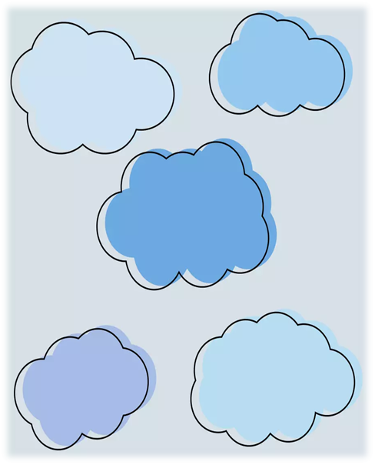


Visit the British Academy of Audiology Tinnitus Toolkit website for more information: https://baaudiology.org/conference/claire-benton-resources/


For information about latest research and tinnitus treamtment: https://tinnitus.org.uk/tinnitus-treatments/

Oto: Tinnitus and sleep therapy
*In app purchases
Sound library

ReSound Tinnitus Relief (Tinnitus management)
Sound library
Guided meditations
Imagery
Education

MyNoise
*In app purchases
Sound library

Book
Isaiah and the Orchestra of Sounds
Headspace
(Meditation and sleep)
*In app purchases
Mindfulness with kids collection

