BOWEL SCHOOL
BOTTOM MUSCLES EXERCISES OR WHAT WE CALL ‘BUM YOGA’

Homework

Some children (like you) have trouble recognising when they need to have a poo. So it’s important to get you in a good toileting routine.
This means sitting on the toilet same times each day, ideally 30 minutes after each meal. This is when your body naturally would want to have a poo. You should also go to the toilet before bedtime and when you get up in the morning.
Here are the exercises.
You will need to do these, at least once a day, every day
SIT ON THE TOILET FOR 5 MINUTES AND DO 1 MIN OF THE ‘BUM YOGA’ EXERCISES
There are two different exercises.
- Squeezing exercises (to hold the poo in)
- Pushing exercises (to push the poo out)
The squeezing exercises can be done anywhere, anytime and where you like, as your pelvic floor muscles are inside your body and no one can see you exercising.
How to Squeeze in
- Sit on a chair and relax.
- Lower your shoulders and breathe slowly and gently.

Imagine you are trying to stop yourself passing wind (‘fart’) from your bottom.

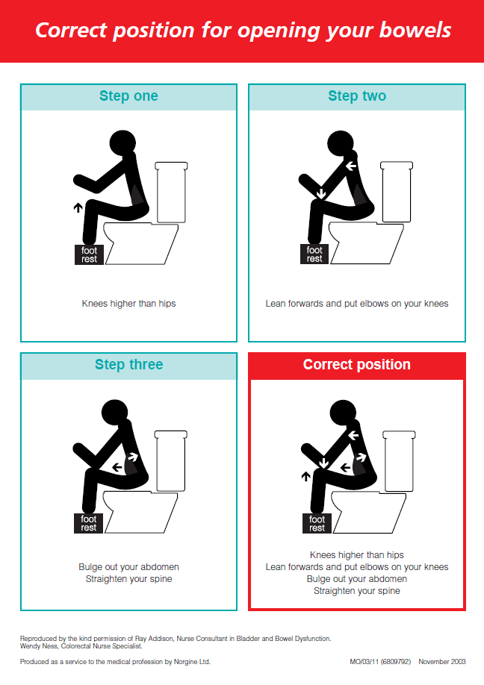

How to hold your poo in?

Sit, stand or lie with your knees slightly apart. Squeeze in and pull up your bottom muscles as tightly as you can. Hold tight for as long as you can. Relax for 10 seconds.

Repeat at least 3 times.

Pushing exercises should be done on the toilet, in case you push a poo out.



How to push a poo out?

Now imagine you’re going to have a poo. Sit comfortably on the toilet, as shown in the picture before.
- Rest your elbows on your knees
- Blow your tummy out
- Push down into your bottom

If you find this difficult, you can blow bubbles or blow into a balloon.

- Gently rocking forwards and backwards and massaging the tummy in clockwise circles can help.

TAKE HOME MESSAGE

Try and do these exercises a few times every day. As the muscle gets stronger you will find that you can squeeze tighter, hold for longer and push better.

Get into the habit of doing the exercises regularly.

DON’T GIVE UP


Bowel School Homework Checklist

Complete this checklist every week, when you’re doing your bowel school homework. It is a checklist to see if you are doing what is needed. Simply tick (√) each task you have done in the box.

WEEK 1

 | Monday | Tuesday | Wednesday | Thursday | Friday | Saturday | Sunday
Correct sitting position
Squeezing exercise x3
Pushing exercises x3
Bowel diary
WEEK 2

 | Monday | Tuesday | Wednesday | Thursday | Friday | Saturday | Sunday
Correct sitting position
Squeezing exercise x3
Pushing exercises x3
Bowel diary
WEEK 3

 | Monday | Tuesday | Wednesday | Thursday | Friday | Saturday | Sunday
Correct sitting position
Squeezing exercise x3
Pushing exercises x3
Bowel diary

WEEK 4

 | Monday | Tuesday | Wednesday | Thursday | Friday | Saturday | Sunday
Correct sitting position
Squeezing exercise x3
Pushing exercises x3
Bowel diary
WEEK 5

 | Monday | Tuesday | Wednesday | Thursday | Friday | Saturday | Sunday
Correct sitting position
Squeezing exercise x3
Pushing exercises x3
Bowel diary

WEEK 6

 | Monday | Tuesday | Wednesday | Thursday | Friday | Saturday | Sunday
Correct sitting position
Squeezing exercise x3
Pushing exercises x3
Bowel diary

Bowel School – Bowel Diary

Name: ___________________________

DOB: ____________________________

How To Complete the Bowel Chart

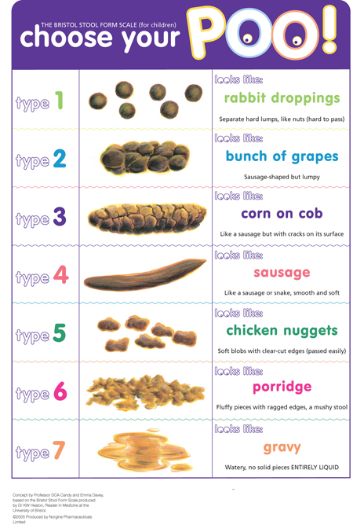
Fill in the chart as accurately as possible for 7 days.
There is an example sheet enclosed, in case you are unsure of how to fill out your charts

- When bowels have been opened, put the approximate time
- Record any pain or discomfort with a tick
- Record the type based on the Bristol Stool Chart on a scale of 1-7(see below)
- Record soiling or accidents with a tick
- Record any day or night wetting with a tick

Example bowel chart
Day | Bowels opened | Time | Type | Pain | Soiling | Any wetting during the day | Bed wetting
1 | Yes | 09:00 | 1 – small pellets | A little | No | No | No
2 | No |  |  | Yes | Yes 3 times | Yes | Yes
3 | Yes | 14:00 | 5 – large amount | no | Yes constant throughout the day | Yes | Yes
4 | Twice | 08:00, 19:00 | 5, 7 – small amount both times | no | No | No | No
5 | No |  |  | Yes | Yes small amount | Yes | No

WEEK 1 Date:
Day | Bowels Opened  (frequency) | Time  AM/PM | Type  (consistency) | Pain | Soiling | Any wetting During the Day | Bed Wetting
1
2
3
4
5
6
7
WEEK 2 Date:
Day | Bowels Opened  (frequency) | Time | Type  (consistency) | Pain | Soiling | Any wetting During the Day
1
2
3
4
5
6
7
WEEK 3 Date:
Day | Bowels Opened  (frequency) | Time | Type  (consistency) | Pain | Soiling | Any wetting During the Day
1
2
3
4
5
6
7
WEEK 4 Date:
Day | Bowels Opened  (frequency) | Time | Type  (consistency) | Pain | Soiling | Any wetting During the Day
1
2
3
4
5
6
7
WEEK 5 Date:
Day | Bowels Opened  (frequency) | Time | Type  (consistency) | Pain | Soiling | Any wetting During the Day
1
2
3
4
5
6
7
WEEK 6 Date:
Day | Bowels Opened  (frequency) | Time | Type  (consistency) | Pain | Soiling | Any wetting During the Day
1
2
3
4
5
6
7

